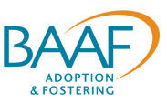

Guidance for the Assessment Framework for Adoption Support

June 2014

©BAAF, 2014
All rights reserved. Except as permitted under the Copyright, Designs and Patents Act 1988, this publication may not be reproduced, stored in a retrieval system, or transmitted in any form or by any means, without prior permission of the publishers.

Contents
Introduction 3
The development of the assessment framework for adoption support 4
The need for adoption support 5
The statutory framework for adoption support 6
The principles underpinning assessments 7
The key stages of the assessment process 9
Referral for an assessment for adoption support 9
Determining eligibility for an assessment for adoption support 10
Planning an assessment for adoption support 11
Undertaking an assessment for adoption support 13
What does the child or young person say and feel about the issues raised in the referral? 13
What does the child/young person think is needed now? 14
What are the key factors in the child's history? 14
What are the key factors in the family's history? 15
What are the family’s strengths 15
What or who are the family’s main sources of support? 16
What are the primary issues of concern? 16
What areas of the child’s and family’s functioning are affected? 16
What might explain these issues? 18
What has already been tried to resolve these issues and how effective have these measures been? 18
What do the parent/s think is needed now and what are the desired outcomes? 18
Does everyone agree? 19
Formulation of the Adoption Support Plan and Recommendations 19
Analysis of key information 19
Recommendations 19
Further assessment 20
Notification of proposals and decisions 20
Notice of Proposal to Provide Adoption Support Services 20
Notification of Decision as to Adoption Support Services 21
Key references 22
Appendix 1 23
Appendix 2 24
Appendix 3 25
Appendix 4 26

Introduction
This guidance provides information and advice for practitioners who will be assessing the support needs of adoptive children and their families in the local authorities involved in the prototyping of the Adoption Support Fund (ASF). It aims to enable practitioners to carry out their assessments in accordance with their statutory duties, determined by the Adoption and Children Act 2002, the Adoption Support Services Regulations, 2005 and Adoption Statutory Guidance.
The development of the framework has been supported by the Department for Education (DfE) as part of its wider Adoption Support Fund (ASF) project. The ASF is a key component of the government’s Adoption Reform Programme and one of its objectives is to improve access to and delivery of adoption support services. The Fund is specifically focused on increasing the availability of ‘therapeutic’ support services. Local authorities will be able to make applications to the ASF if, following their assessment, they identify the child’s support needs as ‘therapeutic’.
DfE has recognised that the future success of the ASF will in part be determined by the quality of local authorities’ assessments of adoptive families’ needs for support. The ASF prototyping local authorities include the highest performing adoption agencies in England and it is expected that they are likely to be currently delivering high-quality assessments. DfE and BAAF are therefore keen for this new assessment framework to be trialled by the ASF prototyping authorities in advance of the national roll out of the Fund later in 2015. The trial should then help further develop an assessment framework that is ‘fit for purpose’ for all local authorities when the national Fund is established.
During the trial BAAF will be offering support to the proto-typing local authorities, and drawing on their experiences of using the new framework or incorporating it into their current frameworks.

The development of the assessment framework for adoption support
The new framework has been developed to reflect best practice in the use of current primary and secondary legislation for adoption support assessments. The development of the framework has been informed by research evidence on adoption support, assessment for adoption support services, and assessment for children’s services more generally. BAAF has also consulted with expert practitioners, consultants and academics from a range of disciplinary backgrounds, including child psychiatry, psychology and social work. Early ideas about, and drafts of, the framework were tested with groups of adoption practitioners who regularly come together at BAAF. DfE and the Expert Advisory Group for the ASF have also been consulted.
The framework's process maps and Pro-forma have been reviewed during May and early June 2014 at meetings and workshops with representatives from the prototyping local authorities, and subsequently revised.
Please email comments and suggestions for further changes to the framework, including the draft Guidance, to Caroline Thomas, Adoption Consultant for BAAF at: caroline.thomas@baaf.org.uk

The need for adoption support
Most children adopted in recent years are likely to have experienced a broad range of pre-natal, infant and/or early-childhood adversities. They will have experienced separation from attachment figures. They may also have lost significant relationships in their lives, experienced some form of neglect and/or maltreatment; been exposed to pre-natal drug and/or alcohol abuse; been exposed to poor maternal health and/or nutrition; and/or inherited a predisposition to mental health problems.
A growing body of research suggests that exposure to pre-natal, neo-natal or childhood stresses and maltreatment can have long-lasting negative neuro-biological and endocrine effects and may affect children’s emotional, cognitive, educational and behavioural development. More particularly, children’s experiences of adults prior to their adoptive placements may mean that they are generally uneasy, wary and fearful, and unable to communicate their needs clearly. They may relate to the adoptive parents in ways that are rejecting, persistently non-compliant, violent and/or aggressive.
Adoptive parents may need the support of a range of universal and specialist services to bolster their resources to help with the children’s developmental recovery and create a secure and meaningful family life. The children themselves may also need help beyond that offered within their new families. The support needed may be psychologically ‘therapeutic’. It may also or alternatively be of a health, educational, practical or financial nature. A family’s needs may well be complex and need careful exploration and discussion. These needs are also likely to change as they adjust and re-adjust to the children’s development over time (Thomas, 2013).

The statutory framework for adoption support
In response to a growing recognition of the need for adoption support, the Adoption and Children Act 2002 and its supporting regulations gave local authorities a duty to make a range of services available to meet the needs of people affected by adoption – before, during and after adoption. Section 2(6) of the Act defined adoption support services as counselling, advice and information, and any other service prescribed by the legislation.
The services prescribed by the Act are:
- financial support
- services to enable groups of adopted children and their families to discuss adoption
- assistance for contact, including mediation services,
- services for the therapeutic needs of an adopted child
- assistance for ensuring the continuance of the relationship between an adoptive child and their adoptive parents
- assistance for placements that have disrupted or are in danger
of disrupting
The Adoption Support Services Regulations 2005 that accompanied the Act offered people affected by adoption the right to request and receive an assessment of their needs for adoption support services. Regulations 13 to 18 set out the related steps required to:
- undertake an assessment and formulate a service plan
- assure quality
- make decisions about service provision
- monitor the outcomes of assessments

The principles underpinning assessments
Assessments for adoption support should be underpinned by the following key principles:
Child-centred: The direct involvement of children in social work processes has been found to improve the quality of professional decision making, and can be developmentally beneficial for the children (Macleod, 2008). Over the last 40 years, children’s rights to be involved in professional decision making processes about their own care have become firmly established in law. The 1989 United Nations Convention on the Rights of the Child – an international statement on civil, political, economic and social rights of children ratified by the UK government – emphasises children’s rights to be heard. Subsequent legislation, including the Adoption and Children Act 2002 and its suite of regulations and guidance, has embedded children’s legal rights to be involved in assessments and other social work processes.
Supportive: Being assessed can be experienced as stressful and demanding by all those involved, and families need a range of information, timely responses, reassurance, and perhaps practical help and support, to facilitate them through the process. In particular, everyone involved needs a clear explanation of their role in the process and what happens at each stage.
Non-blaming: Most people being assessed have anxieties about being judged or blamed by professionals and research suggests that these feelings may be particularly acute in the context of adoption-related assessments. Adoptive parents should not be judged by, or made to feel pushed out of, the process. They need assessors to recognise how hard it is to parent a child who is unhappy and/or challenging, and to show care and concern for them as well as for the child.
Engaging: Assessments need to engage all family and household members to ensure that the process is both child-and family-centred. Family and household members, however, may not necessarily need to be seen together - it may be helpful for some to be seen separately.
To promote adopters’ engagement, they should also be given the opportunity to participate fully and, where appropriate, to take the lead in guiding the assessment and providing information. This could, for instance, involve offering them the chance to begin the drafting of parts of the Pro-forma.
Listening: Assessments need to involve careful and active listening by all the professionals involved, particularly to the voices of the adopted children as well as their adoptive parent(s) and other significant people.
Transparent: The assessment process itself needs to be transparent. There also needs to be openness where services are not available and when children do not meet the thresholds for service provision.
If children’s needs are complex and/or difficult to understand, then parents also need honest explanations about professionals’ uncertainties about what would help. The assessor may need to acknowledge that many issues within adoptive families are not easily resolved, without appearing to abandon the family. Some assessments may require further assessments by other professionals or specialist services.
Adoption informed: Assessments need to be ‘adoption informed’. All professionals involved need to understand and acknowledge the particular issues that adopted children and their families may face that relate to adoption and childhood maltreatment.
Sensitive to differences: Assessments need to be sensitive to differences within and between families. For instance, the process needs to recognise particular issues that may be faced by same-gender adoptive parents, and families with members from different ethnic and/or mixed ethnicity backgrounds.
Avoid repetition: children and their families should only have to provide information once during the assessment process. Information should be shared appropriately with other professionals involved in the assessment and potential service provision, unless there are good reasons why it should not be shared. Adoptive families should not find themselves being asked to repeat information they have provided earlier in the assessment process.

The key stages of the assessment process
There are six key stages to the assessment process which are determined by the Adoption Support Service Regulations 2005:
- referral for an assessment
- determining eligibility for an assessment
- planning an assessment
- undertaking an assessment
- formulating the adoption support plan and recommendations
- notifying the family of proposals and decisions
The Pro-forma for the framework is divided into corresponding parts.
The key stages are mapped out in Appendices 1 to 4.

Referral for an assessment for adoption support
Referrals for an assessment for adoption support are determined by Regulation 13 of the Adoption Support Services Regulations 2005.
Part 1 of the Pro-forma is to be completed for all referrals for an assessment for adoption support.
Part 1 ensures the recording of key information about the adopted child (or children) to whom the referral applies, including:
- The child’s first name, family name, date-of-birth, gender and ethnicity.
- The date the child was placed for adoption, date of their adoption order, and name of their placing agency.
- A brief summary of the referral which notes the primary issues of concerns.
- The name, gender and ethnicity, of the adults and children in the family or household, plus their dates of birth and ages of the children.
- The legal relationship of each adult and child to the adopted child (ren) to ensure clarity about parental responsibility and sibling relationships.
- The family’s contact details and those of the assessing social worker and their manager.
- The contact details of the family member, agency or organisation that made the referral; the date the referral was made and, if appropriate, the date the family was informed of the referral.
Families can refer themselves to an adoption agency for an assessment of their support needs, but there are other routes via general practitioners, pre-school services, schools, Special Educational Needs services, or from within children’s services via children in need or safeguarding teams.
There may be occasions when a family is unaware that a referral for an assessment for adoption support has been made. For instance, if a safeguarding issue arises at school, staff may contact the local authority adoption service without discussing their concerns with the adoptive parents. In such cases it is essential that there are discussions with the family about the referral at the earliest opportunity.

Determining eligibility for an assessment for adoption support
Section 4 of the Adoption and Children Act 2002 and Regulation 13 of the Adoption Support Services Regulations 2005 identify those who are eligible for an assessment for adoption support and sets out how their eligibility should be determined.
Part 2 of the Pro-forma relates to determining eligibility for an assessment for adoption support and is to be completed for all referrals.
If a child has been placed within the local authority by another local authority or voluntary adoption agency, then the responsibility for assessing support needs remains with the placing authority for the first three years after the making of the Adoption Order, unless the referral is for an assessment for financial support. A local authority is therefore responsible for assessing a child who has:

- been placed and remains living within its geographical boundary
- been placed within the local authority by another adoption agency and it is more than three years since the making of their Adoption Order
- moved into the area more than three years after the making of their Adoption Order
Some families might therefore request an assessment for support but be ineligible for one. High proportions of children are placed for adoption out of their local authorities areas and many adoptive families move between local authority areas over the course of their family lives.
Families that request an assessment but are ineligible will need to be referred to the responsible local authority, or supported to access alternative relevant service provision.
If the family is eligible for an assessment and the request is for a specific service, or if they have needs that can be met by referral to a particular service, then a limited assessment can be undertaken. The completion of Parts 3 to 5 of the Pro-forma is not required in such cases.
A note should be made at the end of Part 2 of the Pro-forma of the dates that the family was:
- informed of ineligibility and a referral made to the responsible LA, or
- referred to an adoption support service, or
- informed of eligibility for an assessment.

Planning an assessment for adoption support
The procedure for planning an assessment is determined by Regulation 14 of the Adoption Support Services Regulations 2005.
A full assessment must be undertaken in accordance with the regulations if the information provided in the referral indicates that services may be needed that go beyond brief counselling or advice and information. In such cases the completion of Part 3 of the Pro-forma is required relating to the planning stage.
In planning an assessment, the objectives should be clarified and consideration given to how it should be effectively undertaken, allowing for an exploratory and iterative process that is underpinned by the principles set out above.
Decisions need to be taken about who should be involved and whether the child needs to be seen separately from other members of the adoptive family. The roles of any professionals involved in the process need to be clarified and a decision taken about who should lead the assessment. Consideration needs to be given to any specific factors which may need to influence the way in which the assessment interview(s) are conducted (e.g. a child’s disabilities). The location of the assessment also needs to be determined. The number of meetings needed with family members during the assessment period needs to be estimated.
Brief information also needs to be gathered and noted about any other agencies currently involved with the adoptive family, and permissions sought for the sharing of information across agencies.
The plan for the assessment must be communicated to the family providing details of:
- the person undertaking the assessment and their designation.
- the time, date, likely duration, and place of the assessment interview(s).
- the family members who are invited to participate in the assessment interview(s).
- professionals who have been invited to participate in the assessment interview(s).
- a description of the form of the assessment interview(s).
- the steps that will be taken following the assessment, including an opportunity to make representation on the accuracy and content of the report and the local authority’s proposal for the provision of services.
It would be helpful to send an explanatory leaflet setting out these steps to accompany the specific plan.

Undertaking an assessment for adoption support
The procedure for undertaking an assessment is determined by Regulation 14 of the Adoption Support Services Regulations 2005.
The assessment should aim to create a shared understanding of the family’s primary issues of concern to inform the formulation of any adoption support plan and service specification. While assessment inevitably involves the collection and making sense of information, the experience of being assessed means that the assessing social worker needs to convey empathy and sensitivity. They need to be respectful of the anxieties and concerns of the family, and able to listen to what may be a difficult and troubling narrative.
The headings in Part 4 of the Pro-forma are indicative of the key issues that need to guide information gathering. They are intended to be used on a selective basis - only those that are relevant to a specific assessment should be addressed.

What does the child or young person say and feel about the issues raised in the referral?
Exploring a child or young person's feelings about difficulties within their adoptive family is an important part of the assessment process but can often be challenging to do well. There may be practical difficulties that need to be overcome in ascertaining the wishes and feelings of young children, particularly those under five, and children with communication impairments, or children whose first language is not English. But age is only one factor and many children and young people will have anxieties about expressing their thoughts, feelings and experiences to a stranger.
Practitioners may need to use age-appropriate tools to assist communication such as stories, play and props, and computer-based programmes. Help may also be needed from someone with specific knowledge of the child’s or young person’s communication skills or an interpreter. Individual children’s cognition, memory and language skills all need to be taken into account in the selection of these tools and methods (Macleod, 2008).
Listening to and working with individual children is about more than just offering them the right to contribute their views. They are central to the assessment and this means working with them to understand their thoughts, feelings and experiences and the sense they make of their everyday lives in their adoptive families and beyond. Their perspective on the issues leading up to the referral and what they think might help is crucial to the assessment. It is also important that they have an opportunity to talk about things that are going well and of which they are proud, and what they enjoy and value. The social workers’ skills, empathy, support, engagement and respect in their work with the child or young person, as well as the adults, will be key to the assessment being done well.
For the assessing social worker, their understanding of child and adolescent development in the context of adoption and particularly their insight into the impact of neglect and abuse will be very important. This will be vital in making sense of the child or young person’s contribution.

What does the child/young person think is needed now?
The child or young person is likely to have their own views on what they think they need or want. They will express them in their own way. Some may not know what they need or want. Sometimes what they say may be difficult to understand or seem unhelpful, unrealistic or even dangerous. Whatever concerns or anxieties the assessing social worker might have about what the child wants to happen next, it is important to acknowledge to the child or young person that what they have said has been listened to and will be given careful consideration.

What are the key factors in the child's history?
Historic information about a child and their birth and adoptive families can make a significant contribution to an understanding of an adoptive family's present circumstances. Information about the adversities a child experienced in the past may offer the key to understanding their current behaviour and unmet developmental needs. A chronology can be particularly helpful to assessors in making connections between a child's past events and their subsequent psychosocial development (Helm, 2012).
Accessing information held in a child's case file records can, however, be a lengthy process, particularly if the child was placed for adoption by another authority. If problems are encountered in accessing historic records, the benefits of a longer-term perspective on the case needs to be carefully weighed against the costs of delays in the assessment process, and a decision may need to be taken to proceed without them.

What are the key factors in the family's history?
Key factors in the child’s history – both pre and post placement - and the adopter/s’ history – both pre and post placement - are likely to be important in explaining the current challenges. Identifying these key factors and understanding how they interact is challenging.
A child’s history can raise issues from the adopters’ past. It can provoke associations and feelings in adoptive parents and other members of the household, which can in turn have a significant affect on their feelings and behaviours towards the adopted child. Loss, disappointment, frustration and upset are likely to be a part of the narrative of assessments. Identifying the interaction between family members’ past and present is an important part of understanding such feelings.

What are the family’s strengths
Asking for adoption support usually means focussing on difficult, upsetting or disturbing aspects of family life. It is important that the family has enough opportunities during the assessment to explore and explain them. However, it is also important that what is not going well is set within the context of the family’s strengths. Family members should be encouraged to speak about what they think is going well. It is very important that positive recognition is given to the family’s strengths.

What or who are the family’s main sources of support?
Members of the adoptive family’s wider family, and their friends and local community are usually important sources of support for the adoptive family. Identifying who they are and what they offer can be an important part of understanding the family’s strengths.
Sometimes members of these social networks do not understand or cannot relate to the special needs of adopted children. They may be concerned that the adopted child’s behaviour poses a threat to, or is difficult for, their own children. They may perceive the adopters as poor parents and be critical. Such responses can be very difficult for adoptive parents. A lack of understanding can reduce the size and strength of the support network and thereby add to the demands on them. It can also deny the adopted child the positive experiences that come through being accepted into the community of family and friends (Miller and Bentovim, 2007).
In some assessments, members of the adoptive family’s social network may play an important part in providing information and identifying the support that might be needed.

What are the primary issues of concern?
It is likely that the referral will focus on one area of concern. However, it may quickly become apparent during the assessment that there are a number of connected issues or the original issue is only one part of a more complex set. Identifying those that are of primary concern may therefore be challenging particularly if problems have evolved over a long period. But it is important as the assessment progresses that the formulation of the family’s needs for support gives a focus and priority to what happens next.

What areas of the child’s and family’s functioning are affected?
In identifying the primary issues of concern, it is important to understand which areas of the child or the family’s functioning are going well and not so well. These areas might include:
- Daily routines - including mealtimes, bedtimes, getting dressed, washing, personal hygiene, and tidying up.
- Playtime, leisure and interests in the home and outside.
- Relationships between the child and adopter/s and other children in the family - including appropriate levels of intimacy, recounting and sharing daily events, fun and family activities such as celebrations and festivals.
- Relationships outside of the home with extended family members, and other children - including sources of stress such as bullying.
- Management of behaviour and emotions - including boundary setting, emotional regulation/dys-regulation, conflict resolution, sensitivity and empathy, and making decisions.
- Management of transitions, loss and change - including school, family membership, stages of child and adolescent development, and leaving home.
- Physical health and development.
- Learning and education - including being settled in the classroom and in school.
- Exploring and explaining the past and the impact of the past on the present - including the management and meaning of adoption-related information and events including indirect and direct contact. The development of and current issues in life story work.
- Formation of meaningful identities - including an adoption identity, gender, sexuality, ethnicity, and religion.

What might explain these issues?
Difficulties and stresses in any of these areas of family functioning may be explained by the:
- impact of the child’s past - particularly their experience of multiple forms of early adversity.
- family’s approach – which may be linked to their current levels of understanding of adoption and/or parenting strategies.
- difficulties in engaging appropriate support – from local authorities/schools/health of other services.
- feelings of being overwhelmed and stressed by the length of time and/or intensity of the difficulties they have experienced, including a sense of feeling alone and isolated, maybe from their partner or other family members.

What has already been tried to resolve these issues and how effective have these measures been?
It will be important to understand what the family has already done to try to resolve issues. There needs to be an exploration of what has previously been suggested and tried, and the effectiveness of those measures. This might include trying to understanding why the family thinks what has been tried proved to be of limited use, or its effectiveness disappeared over time.

What do the parent/s think is needed now and what are the desired outcomes?
The family’s experience of addressing problems in the past and their further exploration of the issues through discussion, reading, and use of the internet may mean that they have a clear view about what is needed. But they may have uncertainties and question whether anything can be done that would be helpful. In exploring possible interventions with them, it is important that the desired outcomes are considered in ways that are realistic, and rooted in the present but informed by the past.

Does everyone agree?
There may be agreement about the primary issues, their causes and/or possible solutions, but there may be differing views. For instance, the adoptive parents may have different perspectives from one another, or the child may see things very differently from the rest of the family. The professionals involved in the assessment may not agree between themselves and/or may disagree with members of the adoptive family. The assessing social workers’ observations in the family home may provide information that differs from that of the adoptive parents. Any differences of view need which emerge during the process need to be acknowledged and explored carefully, and attempts made to create a consensus about the primary issues and the support that is needed to address them.

Formulation of the Adoption Support Plan and Recommendations

Analysis of key information
It is widely acknowledged that the purpose of an assessment in social work is to collect relevant information and understand its significance. Information overload, repeated information, and information stated just because it is available, is unhelpful. Acknowledging what is not known is a key part of an assessment.
‘Coming to a view’ about the needs in the family must be based on the evidence available. The evidence needs to be sifted and formed into a coherent and meaningful narrative of the primary issues. ‘This is what matters’ and ‘this is why it matters’ is the objective of the analysis.

Recommendations
The analysis of needs will inform recommendations about services to address any identified needs. Recommended services will need to deliver agreed outcomes in a reliable and effective way.
Inevitably some families’ needs for support will not easily lend themselves to clear evidence-based interventions. Some interventions may provide them with relief, an improvement, or be experienced as supportive or generally beneficial, but will not offer a corrective solution or ‘cure’. Where this is so, the recommendations for service provision need to be informed by a careful weighing of the evidence and realistic appraisal of the likely outcomes.

Further assessment
If as a result of the assessment, the social worker comes to a view that the child and family’s needs are such that they need require exploration and clarification, then the outcome might be to commission a further assessment. This may be so where it is apparent that there are issues that require particular professional expertise from health, mental health of education specialists.
The details about the proposed further assessment should be recorded on page 10 of the Pro-forma. This should include a note of the issues requiring further clarification, who should undertake the further assessment, and whether an application will be made to the Adoption Support Fund to fund the further assessment. The proposal for the further assessment has to be agreed by the Adoption Support Services Adviser (ASSA).

Notification of proposals and decisions

Notice of Proposal to Provide Adoption Support Services
The preparation of the adoption support plan is determined by Section 4(5) of the Adoption and Children Act 2002 and Regulations 16 and 17 of the Adoption Support Services Regulations 2005.
An ‘Assessment of Adoption Support Needs Report’ is required and will be based on the analysis of key information and recommendations noted on page 9 of the Pro-forma.
Where the proposed service falls within the scope of the Adoption Support Fund and the local authority propose to make a referral to the Fund this should be noted in the report.
The ‘Assessment of Support Needs Report’ will need to be quality assured by the ASSA.
Before the local authority makes any decisions to provide services, the family must be sent a copy of the assessment together with any recommendations to provide services and the draft plan to provide those services. The plan is to be noted on page 11 of the Pro-forma.
The family must be given reasonable time to comment the report. Regulation 17 (1-5). Comments are to be noted on page 13 of the Pro-forma.

Notification of Decision as to Adoption Support Services
Following the receipt of the family’s comments on the assessment and the proposal to provide services, the local authority will make its decision about the final form of the services to be provided, the plan for those services, and the person identified to monitor the outcomes from that plan (Regulation 16). The notification is to recorded on page 14 of the Pro-forma.
Where an application to the Adoption Support Fund has been agreed, that should be noted in the plan.

Key references
Bingley Miller L and Bentovim A (2007) ‘Assessing the support needs of adopted children and their families: building secure new lives’ Oxon: Routledge
Department for Education (2013) Press Release for Adoption Support Fund: https://www.gov.uk/government/news/new-193-million-support-fund-for-adoptive-parents
Ford T, Vostanis P, Meltzer H and Goodman R (2007) ‘Psychiatric disorder among British children looked after by local authorities: comparison with children living in private households’ British Journal of Psychiatry 190: 319-325
Helm D (2010) ‘Making sense of child and family assessment: how to interpret children’s needs’ London: Jessica Kingsley Publishers
Holmes L, McDermid S and Lushey C (2013) Post-adoption support: A rapid response survey of local authorities in England: Working Paper no. 19, Childhood Well Being Research Centre, Loughborough University 47
Howe D (2009) ‘The impact of histories of abuse and neglect on children in placement’ in The Child Placement Handbook: Research, Policy and Practice (eds.) Schofield G. and Simmonds J., London: BAAF
McLeod A (2008) ‘Listening to children: A practitioners guide’ London: Jessica Kingsley Publishers
Thomas C (2013) ‘Adoption of looked after children: messages from research’ London: BAAF

Appendix 1
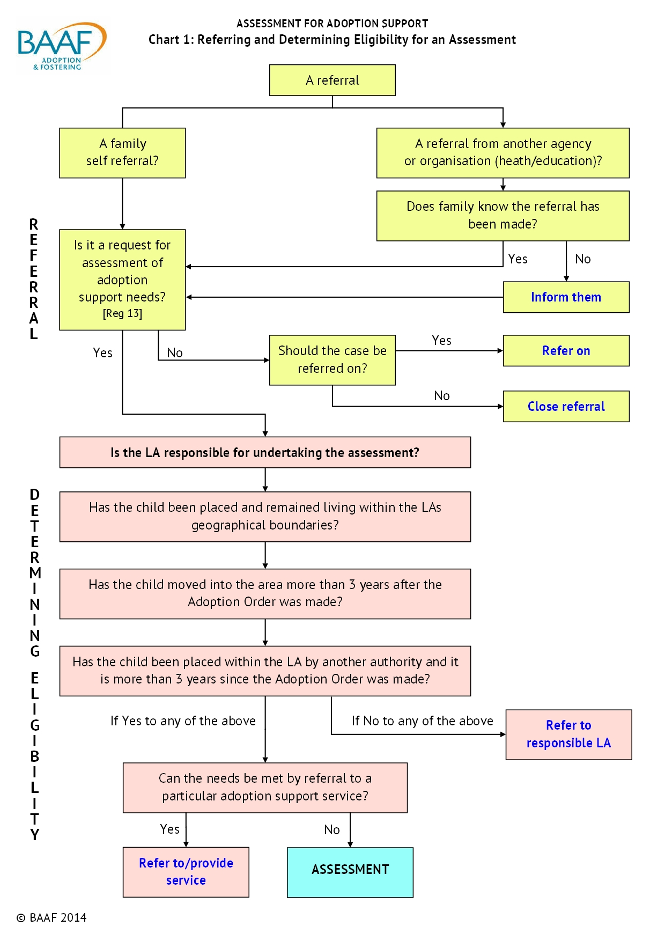

Appendix 2
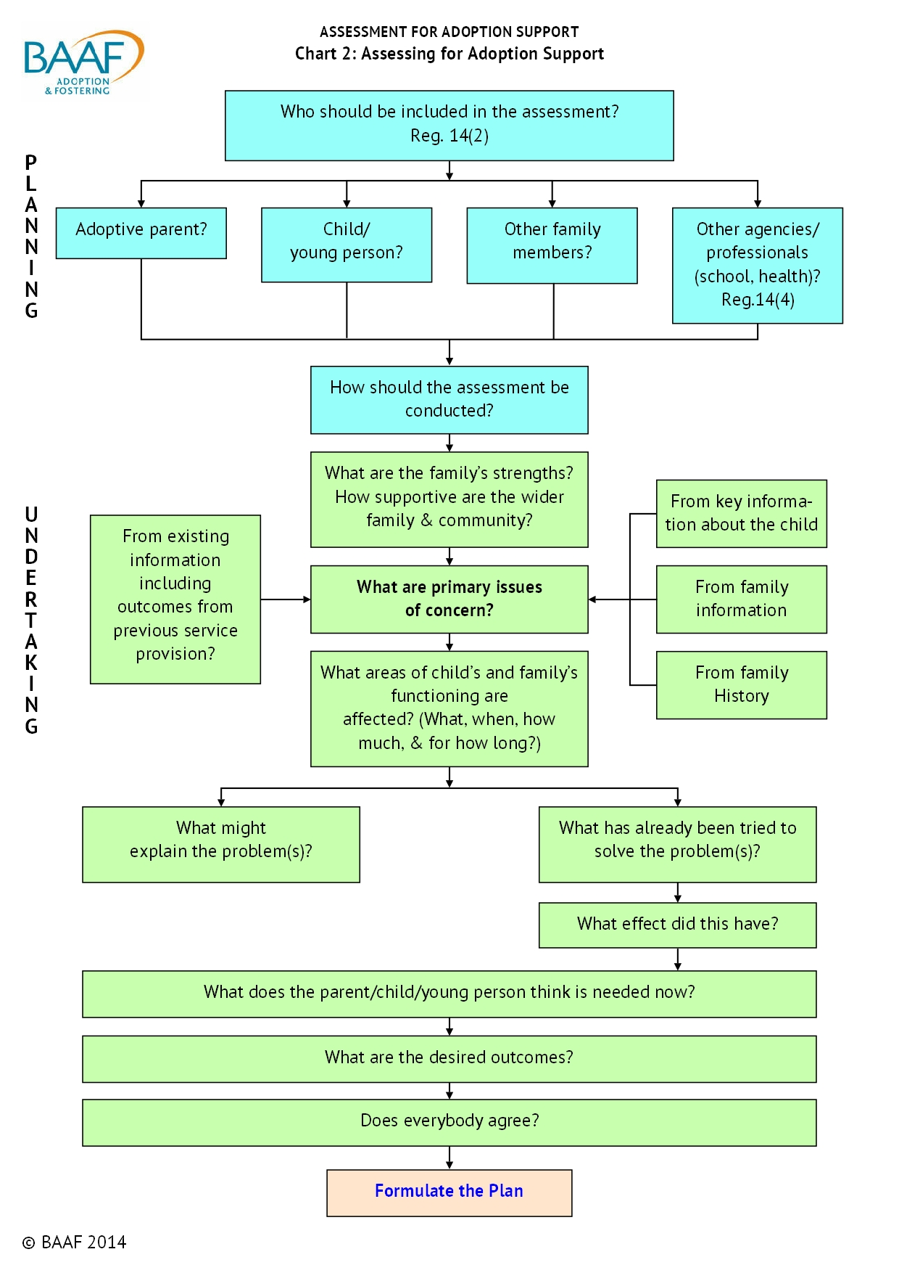

Appendix 3
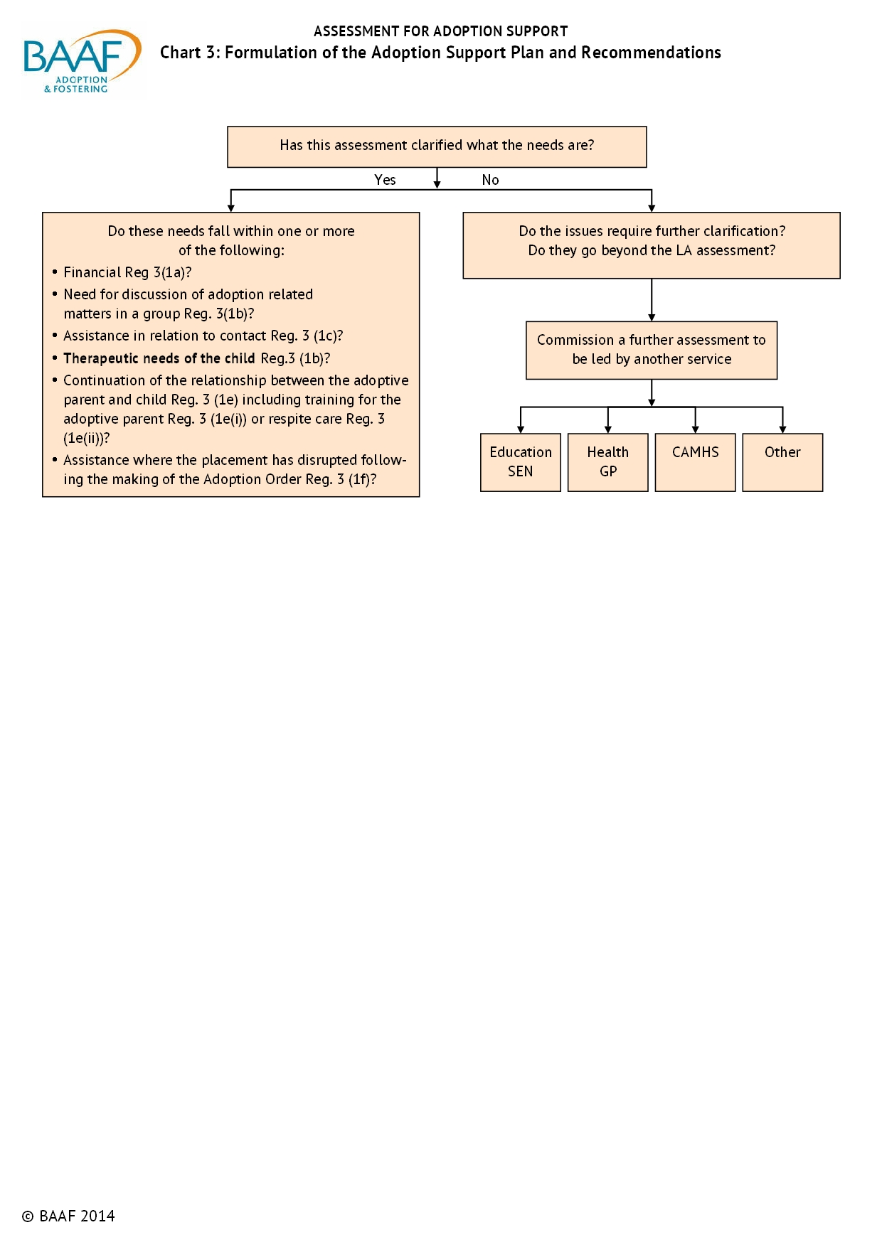

Appendix 4
